REPORT Z.

PARAMETERS:PEMPNO(4) TYPE N,

PENAME(10) TYPE C.

AT SELECTION-SCREEN OUTPUT.

LOOP AT SCREEN.

IF SCREEN-NAME = 'PENAME'.

SCREEN-INPUT = 0. "Cannot enter values if screen-input is 0

MODIFY SCREEN.

ENDIF.

ENDLOOP.

START-OF-SELECTION.

WRITE :/ 'Ename is :', PENAME.

WRITE :/ 'Empno is :', PEMPNO.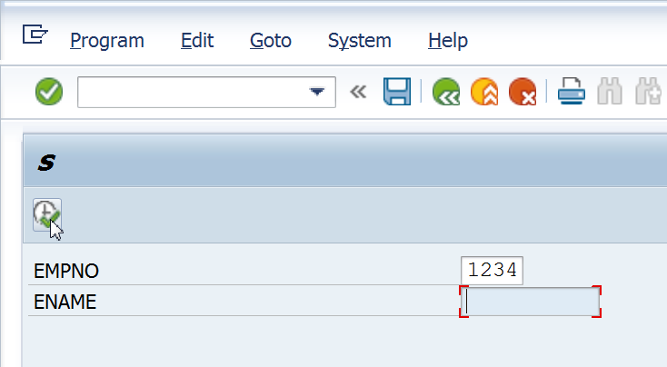

No Data Entry is allowed in Ename.

If the above is changed to SCREEN-INPUT = 1, data entry will be allowed, and a screen as shown below, will be seen.

